Given two n x n binary matrices mat and target, return true*if it is possible to make*mat*equal to*target*by****rotating***mat*in****90-degree increments****, or*false*otherwise.*

**Example 1:**

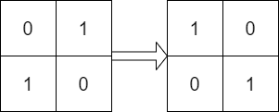

**Input:** mat = [[0,1],[1,0]], target = [[1,0],[0,1]]

**Output:** true

**Explanation:** We can rotate mat 90 degrees clockwise to make mat equal target.

**Example 2:**

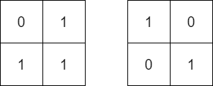

**Input:** mat = [[0,1],[1,1]], target = [[1,0],[0,1]]

**Output:** false

**Explanation:** It is impossible to make mat equal to target by rotating mat.

**Example 3:**

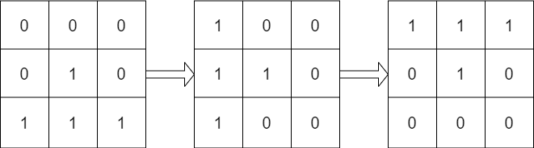

**Input:** mat = [[0,0,0],[0,1,0],[1,1,1]], target = [[1,1,1],[0,1,0],[0,0,0]]

**Output:** true

**Explanation:** We can rotate mat 90 degrees clockwise two times to make mat equal target.

**Constraints:**

* n == mat.length == target.length
* n == mat[i].length == target[i].length
* 1 <= n <= 10
* mat[i][j] and target[i][j] are either 0 or 1.